Marco Polo and His Travels

"When a man is riding through this desert by night and for some reason -falling asleep or anything else -he gets separated from his companions and wants to rejoin them, he hears spirit voices talking to him as if they were his companions, sometimes even calling him by name. Often these voices lure him away from the path and he never finds it again, and many travelers have got lost and died because of this. Sometimes in the night travelers hear a noise like the clatter of a great company of riders away from the road; if they believe that these are some of their own company and head for the noise, they find themselves in deep trouble when daylight comes and they realize their mistake. There were some who, in crossing the desert, have been a host of men coming towards them and, suspecting that they were robbers, returning, they have gone hopelessly astray....Even by daylight men hear these spirit voices, and often you fancy you are listening to the strains of many instruments, especially drums, and the clash of arms. For this reason bands of travelers make a point of keeping very close together. Before they go to sleep they set up a sign pointing in the direction in which they have to travel, and round the necks of all their beasts they fasten little bells, so that by listening to the sound they may prevent them from straying off the path."
---- Marco Polo, Travels
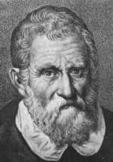
Marco Polo (1254-1324), is probably the most famous Westerner traveled on the Silk Road. He excelled all the other travelers in his determination, his writing, and his influence. His journey through Asia lasted 24 years. He reached further than any of his predecessors, beyond Mongolia to China. He became a confidant of Kublai Khan (1214-1294). He traveled the whole of China and returned to tell the tale, which became the greatest travelogue.
The Polo Brothers
In 1260 two Venetian merchants arrived at Sudak, the Crimean port. The brothers Maffeo and Niccilo Polo went on to Surai, on the Volga river, where they traded for a year. Shortly after a civil war broke out between Barka and his cousin Hulagu, which made it impossible for the Polos to return with the same route as they came. They therefore decide to make a wide detour to the east to avoid the war and found themselves stranded for 3 years at Bukhara.
The marooned Polo brothers were abruptly rescued in Bukhara by the arrival of a VIP emissary from Hulagu Khan in the West. The Mongol ambassador persuaded the brothers that Great Khan would be delighted to meet them for he had never seen any Latin and very much wanted to meet one. So they journeyed eastward. They left Bukhara, Samarkand, Kashgar, then came the murderous obstacle of the Gobi desert. Through the northern route they reached Turfan and Hami, then headed south-east to Dunhuang. Along the Hexi Corridor, they finally reached the new capital of the Great Khan, Bejing in 1266.
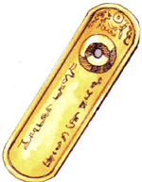
The Great Khan, Mangu's brother, Kublai, was indeed hospitable. He had set up his court at Beijing, which was not a Mongol encampment but an impressive city built by Kublai as his new capital after the Mongols took over China in 1264 and established Yuan dynasty (1264-1368). Kublai asked them all about their part of the world, the Pope and the Roman church. Niccolo and Matteo, who spoke Turkic dialects perfectly, answered truthfully and clearly. The Polo brothers were well received in the Great Khan's capital. One year later, the Great Khan sent them on their way with a letter in Turki addressed to Pope Clement IV asking the Pope to send him 100 learned men to teach his people about Christianity and Western science. He also asked Pope to procure oil from the lamp at the Holy Sepulchre in Jerusalem.
To make sure the brothers would be given every assistance on their travels, Kublai Khan presented them with a golden tablet (or paiza in Chinese, gerege in Mongolian) a foot long and three inches wide and inscribed with the words (Left Fig.): "By the strength of the eternal Heaven, holy be the Khan's name. Let him that pays him not reverence be killed." The golden tablet was the special VIP passport, authorizing the travelers to receive throughout the Great Khan's dominions such horses, lodging, food and guides as they required. It took the Polos three full years to return home, in April 1269.
Although the Polo brothers blazed a trail of their own on their first journey to the East, they were not the first Europeans to visit the Mongols on their home ground. Before them Giovanni di Piano Carpini in 1245 and Guillaume de Rubrouck in 1253 had made the dangerously journey to Karakorum and returned safely; however the Polos traveled farther than Carpini and Rubrouck and reached China.
Marco Polo's Birth and Growing Up
According to one authority, the Polo family were great nobles originating on the coast of Dalmatia. Niccolo and Maffeo had established a trading outpost on the island of Curzola, off the coast of Dalmatia; it is not certain whether Marco Polo was born there or in Venice in 1254. The place Marco Polo grew up, Venice, was the center for commerce in the Mediterranean. Marco had the usual education of a young gentleman of his time. He had learned much of the classical authors, understood the texts of the Bible, and knew the basic theology of the Latin Church. He had a sound knowledge of commercial French as well as Italian. From his later history we can be sure of his interest in natural resources, in the ways of people, as well as strange and interesting plants and animals.
Marco Polo was only 6 years old when his father and uncle set out eastward on their first trip to Cathay (China). He was by then 15 years old when his father and his uncle returned to Venice and his mother had already passed away. He remained in Venice with his father and uncle for two more years and then three of them embarked the most couragous journey to Cathay the second time.
The Long and Difficult Journey to Cathay
At the end of year 1271, receiving letters and valuable gifts for the Great Khan from the new Pope Tedaldo (Gregory x), the Polos once more set out from Venice on their journey to the east. They took with them 17-year-old Marco Polo and two friars. The two friars hastily turned back after reaching a war zone, but the Polos carried on. They passed through Armenia, Persia, and Afghanistan, over the Pamirs, and all along the Silk Road to China.

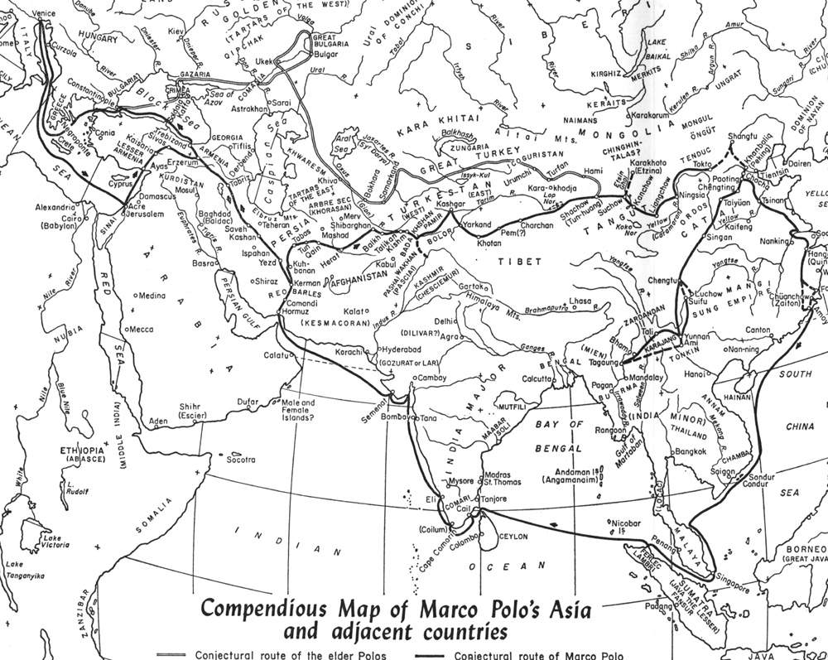
Avoiding to travel the same route the Polos did 10 years ago, they made a wide swing to the north, first arriving to the southern Caucasus and the kingdom of Georgia. Then they journeyed along the regions parallel to the western shores of the Caspian Sea, reaching Tabriz and made their way south to Hormuz on the Persian Gulf. They intended to take sea route to the Chinese port. From Hormuz, however, finding the ships "wretched affairs....only stitched together with twine made from the husk of the Indian nut", they decided to go overland to Cathay and continued eastwards. From Homurz to Kerman, passing Herat, Balkh, they arrived Badakhshan, where Marco Polo convalesced from an illness and stayed there for a year. On the move again, they found themselves on "the highest place in the world, the Pamirs", with its name appeared in the history for the first time.
When the Polos arrived the Taklamakan desert (or Taim Basin), this time they skirted around the desert on the southern route, passing through Yarkand, Khotan, Cherchen, and Lop-Nor. Marco's keen eye picked out the most notable peculiarities of each. At Yarkand, he described that the locals were extremely prone to goiter, which Marco blamed on the local drinking water. In the rivers of Pem province were found "stones called jasper and chalcedony in plenty" - a reference to jade. At Pem, "when a woman's husband leaves her to go on a journey of more than 20 days, as soon as he has left, she takes another husband, and this she is fully entitled to do by local usage. And the men, wherever they go, take wives in the same way." Cherchen was also a noted jade source.
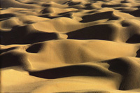
It is the Gobi desert (Right Fig.)where Marco Polo left us the feeling of awe for the vastness of desert and its effects on those hardy enough to penetrate it: "This desert is reported to be so long that it would take a year to go from end to end; and at the narrowest point it takes a month to cross it. It consists entirely of mountains and sands and valleys. There is nothing at all to eat." Despite the dangers encountered during the Gobi crossing, Marco's account suggests that the route was safe and well established during Mongol's reign. After they left Gobi, the first major city they passed was Suchow (Dunhuang), in Tangut province, where Marco stayed for a year. Marco also noted the center of the asbestos industry in Uighuristan, with its capital Karakhoja; he added that the way to clean asbestos cloth was to throw it into a fire, and that a specimen was brought back from Cathay by the Polos and presented to the Pope.
The fact that Marco was not a historian did not stop him offering a long history about the Mongols. He provided a detailed account of the rise of Mongol and Great Khan's life and empire. He described the ceremonial of a Great Khan's funeral - anyone unfortunate enough to encounter the funeral cortege was put to death to serve their lord in the next world, Mangu Khan's corpse scoring over twenty thousand victims. He told of life on the steppes, of the felt-covered yurt drawn by oxen and camels, and of the household customs. What impressed Marco most was the way in which the women got on with the lion's share of the work:"the men do not bother themselves about anything but hunting and warfare and falconry." In term of marriage, Marco described that the Mongols practiced polygamy. A Mongol man could take as many wives as he liked. On the death of the head of the house the eldest son married his father's wives, but not his own mother. A man could also take on his brother's wives if they were widowed. Marco rounded off his account of Mongol's home life by mentioning that alcoholic standby which had impressed Rubrouck before him:"They drink mare's milk subjected to a process that makes it like white wine and very good to drink. It is called koumiss"
Marco's account of the Mongol's life is particularly interesting when compared to the tale of many wonders of Chinese civilization which he was soon to see for himself. Kublai Khan, though ruling with all the spender of an Emperor of China, never forgot where he had come from: it is said that he had had seeds of steppe grass sown in the courtyard of the Imperial Palace so that he could always be reminded of his Mongol homeland. During his long stay in Cathay and Marco had many conversations with Kublai, Marco must have come to appreciate the Great Khan's awareness of his Mongol origins, and the detail in which the Mongols are described in his book suggests that he was moved to make a close study of their ways.
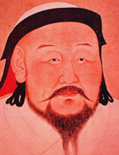
Finally the long journey was nearly over and the Great Khan had been told of their approach. He sent out a royal escort to bring the travellers to his presense. In May 1275 the Polos arrived to the original capital of Kublai Khan at Shang-tu (then the summer residence), subsequently his winter palace at his capital, Cambaluc (Beijing). By then it had been 3 and half years since they left Venice and they had traveled total of 5600 miles on the journey. Marco recalled it in detail on the greatest moment when he first met the Great Khan (Left Fig.):
" They knelt before him and made obeisance with the utmost humility. The Great Khan bade them rise and received them honorably and entertained them with good cheer. He asked many questions about their condition and how they fared after their departure. The brothers assured him that they had indeed fared well, since they found him well and flourishing. Then they presented the privileges and letters which the Pope had sent, with which he was greatly pleased, and handed over the holy oil, which he received with joy and prized very hightly. When the Great Khan saw Marco, who was then a young stripling, he asked who he was. 'Sir' said Messer Niccolo, 'he is my son and your liege man.' 'He is heartly welcome,' said the Khan. What need to make a long story of it? Great indeed were the mirth and merry-making with which the Great khan and all his Court welcomed the arrival of these emissaries. And they were well served and attended to in all their needs. They stayed at Court and had a place of honor above the other barons."
Years Serviced in Khan's Court
Marco, a gifted linguist and master of four languages, became a favorite with the khan and was appointed to high posts in his administration. He served at the Khan's court and was sent on a number of special missions in China, Burma and India. Many places which Marco saw were not seen again by Europeans until last century. Marco went on great length to describe Kublia's capital, ceremonies, hunting and public assistance, and they were all to be found on a much smaller scale in Europe. Marco Polo fell in love with the capital, which later became part of Beijing, then called Cambaluc or Khanbalig, meant 'city of the Khan.' This new city, built because astrologers predicted rebellion in the old one, was described as the most magnificent city in the world. He marveled the summer palace in particular. He described "the greatest palace that ever was". The walls were covered with gold and silver and the Hall was so large that it could easily dine 6,000 people. The palace was made of cane supported by 200 silk cords, which could be taken to pieces and transported easily when the Emperor moved. There too, the Khan kept a stud of 10,000 speckless white horses, whose milk was reserved for his family and for a tribe which had won a victory for Genghis Khan." fine marble Palace, the rooms of which are all gilt and painted with figures of men and beasts....all executed with such exquisite art that you regard them with delight and astonishment." This description later inspired the English poet Coleridge to write his famous poem about Kublai Khan's "stately pleasure-dome" in Xanadu (or Shang-du).
However there were some phenomena which were totally new to him. The first we have already met, asbestos, but the other three beggared his imagination, and they were paper currency, coal and the imperial post.
The idea of paper substituting gold and silver was a total surprise even to the merchantile Polos. Marco attributed the success of paper money to Kublai stature as a ruler. "With these pieces of paper they can buy anything and pay for anything. And I can tell you that the papers that reckon as ten bezants do not weight one." Marco's expressions of wonder at "stones that burn like logs" show us how ignorant even a man of a leading Mediterranean seapower could be in the 13th century. Coal was by no means unknown in Europe but was new to Marco: "
It is true that they have plenty of firewood, too. But the population is so enormous and there are so many bath-houses and baths constantly being heated, that it would be impossible to supply enough firewood, since there is no one who does not visit a bath-house at least 3 times a week and take a bath - in winter every day, if he can manage it. Every man of rank or means has his own bathroom in his house....so these stones, being very plentiful and very cheap, effect a great saving of wood."
Marco was equally impressed with the efficient communication system in the Mongol world. There were three main grades of dispatch, which may be rendered in modern terms as 'second class', 'first class', and 'On His Imperial Majesty's Service: Top Priority'. 'Second class' messages were carried by foot-runners, who had relay-stations three miles apart. Each messenger wore a special belt hung with small bells to announce his approach and ensure that his relief was out on the road and ready for a smooth takeover. This system enabled a message to cover the distance of a normal ten-day journey in 24 hours. At each three miles station a log was kept on the flow of messages and all the routes were patrolled by inspectors. 'First class' business was conveyed on horseback, with relay-stages of 25 miles. But the really important business of Kublai empire was carried by non-stop dispatch-riders carrying the special tablet with the sign of the gerfalcon. At the approach to each post-house the messenger would sound his horn; the ostlers would bring out a ready-saddled fresh horse, the messenger would transfer to it and gallop straight off. Marco affirmed that those courier horsemen could travel 250 or 300 miles in a day.
Marco Polo traveled in great deal in China. He was amazed with China's enormous power, great wealth, and complex social structure. China under the Yuan (The Mongol Empire) dynasty was a huge empire whose internal economy dwarfed that of Europe. He reported that Iron manufacture was around 125,000 tons a year (a level not reached in Europe before the 18th century) and salt production was on a prodigious scale: 30,000 tons a year in one province alone. A canal-based transportation system linked China's huge cities and markets in a vast internal communication network in which paper money and credit facilities were highly developed. The citizens could purchase paperback books with paper money, eat rice from fine porcelain bowls and wear silk garments, lived in prosperous city that no European town could match.
Kublai Khan appointed Marco Polo as an official of the Privy Council in 1277 and for 3 years he was a tax inspector in Yanzhou, a city on the Grand Canal, northeast of Nanking. He also visited Karakorum and part of Siberia. Meanwhile his father and uncle took part in the assault on the town of Siang Yang Fou, for which they designed and constructed siege engines. He frequently visited Hangzhou, another city very near Yangzhou. At one time Hangzhou was the capital of the Song dynasty and had a beautiful lakes and many canals, like Marco's hometown, Venice. Marco fell in love with it.
Coming Home
The Polos stayed in Khan's court for 17 years, acquiring great wealth in jewels and gold. They were anxious to be on the move since they feared that if Kublai - now in his late seventies - were to die, they might not be able to get their considerable fortune out of the country. The Kublai Khan reluctantly agreed to let them return after they escorted a Mongol princess Kokachin to marry to a Persian prince, Arghun.
Marco did not provide full account of his long journey home. The sea journey took 2 years during which 600 passengers and crewed died. Marco did not give much clue as to what went wrong on the trip, but there are some theories. Some think they may have died from scurvy, cholera or by drowning; others suggest the losses were caused by the hostile natives and pirate attacks. This dreadful sea voyage passed through the South China Sea to Sumatra and the Indian Ocean, and finally docked at Hormuz. There they learned that Arghun had died two years previously so the princess married to his son, prince Ghazan, instead. In Persia they also learned of the death of Kublai Khan. However his protection outlived him, for it was only by showing his golden tablet of authority that they were able to travel safely through the bandit-ridden interior. Marco admitted that the passports of golden tablets were powerful:
"Throughout his dominions the Polos were supplied with horses and provisions and everything needful......I assure you for a fact that on many occasions they were given two hundred horsemen, sometimes more and sometimes less, according to the number needed to escort them and ensure their safe passage from one district to another."
From Trebizond on the Black Sea coast they went by sea, by way of Constantinople, to Venice, arriving home in the winter of 1295.
The Book, Life in Venice and Controversies
Three years after Marco returned to Venice, he commanded a galley in a war against the rival city of Genoa. He was captured during the flighting and spent a year in a Genoese prison - where one of his fellow-prisoners was a writer of romances named Rustichello of Pisa. It was only when prompted by Rustichello that Marco Polo dictated the story of his travels, known in his time as The Description of the World or The Travels of Marco Polo. His account of the wealth of Cathay (China), the might of the Mongol empire, and the exotic customs of India and Africa made his book the bestseller soon after. The book became one of the most popular books in medieval Europe and the impact of his book on the contemporary Europe was tremendous. It was known as Il Milione, The Million Lies and Marco earned the nickname of Marco Milione because few believed that his stories were true and most Europeans dismissed the book as mere fable.
In the summer of 1299 a peace was concluded between Venice and Genoa, and after a year of captivity, Marco Polo was released from the prison and returned to Venice. He was married to Donata Badoer and had three daughters. He remained in Venice until his death in 1324, aged 70. At his deathbed, he left the famous epitaph for the world: "I have only told the half of what I saw!" On Marco's will, he left his wife and three daughters substantial amount of money, though not an enormous fortune as Marco boasted. He also mentioned his servant, Peter, who came from the Mongols, was to set free. We also learned that 30 years after his return home, Marco still owned a quantity of cloths, valuable pieces, coverings, brocades of silk and gold, exactly like those mentioned several times in his book, together with other precious objects. Among them there was "golden tablet of command" that had been given him by the Great Khan on his departure from the Mongol capital.
Many people took his accounts with a grain of salt and some skeptics question the authenticity of his account. Many of his stories have been considered as fairytales: the strange oil in Baku and the monstrous birds which dropped elephants from a height and devoured their broken carcasses. His Travels made no mention about the Great Wall. While traveled extensively in China, Marco Polo never learned the Chinese language nor mentioned a number of articles which are part of everyday life, such as women's foot-binding, calligraphy, or tea. In additional, Marco Polo's name was never occurred in the Annals of the Empire (Yuan Shih), which recorded the names of foreign visitors far less important and illustrious than the three Venetians. So did Marco Polo ever go to China?
Contribution
Fiction or not, his Travels has captured readers through the centuries. Manuscript editions of his work ran into the hundreds within a century after his death. The book was recognized as the most important account of the world outside Europe that was available at the time. Today there are more than 80 manuscript copies in various versions and several languages around the world.
We see that Marco Polo was in every way a man of his time. He was quite capable of comprehending cultures completely alien in spirit to his own. Traversing thousands of miles, on horseback mostly, through uncharted deserts, over steep mountain passes, exposed to extreme weathers, to wild animals and very uncivilized tribesmen, Marco's book has become the most influential travelogue on the Silk Road ever written in a European language, and it paved the way for t he arrivals of thousands of Westerners in the centuries to come.
Today there are a school of experts conducting research and authentication of Marco Polo and his Travels. Much of what he wrote, which regarded with suspicion at medieval time was, confirmed by travelers of the 18th and 19th centuries. Marco Polo is receiving deeper respect than before because these marvelous characters and countries he described did actually exist. What's more interesting is that his book becomes great value to Chinese historians, as it helps them understand better some of the most important events of the 13th century, such as the siege of Hsiangyang, the massacre of Ch'angchou, and the attempted conquests of Japan. The extant Chinese sources on these events are not as comprehensive as Marco's book.
Although Marco Polo received little recognition from the geographers of his time, some of the information in his book was incorporated in some important maps of the later Middle Ages, such as the Catalan World Map of 1375, and in the next century it was read with great interest by Henry the Navigator and by Columbus. His system of measuring distances by days' journey has turned out for later generations of explorers to be remarkably accurate. According to Henry Yule, the great geographer: "He was the first traveler to trace a route across the whole longitude of Asia, naming and describing kingdom after kingdom.....". Today topographers have called his work the precursor of scientific geography.
However Marco Polo's best achievement is best said with his own words in his own book:
" I believe it was God's will that we should come back, so that men might know the things that are in the world, since, as we have said in the first chapter of this book, no other man, Christian or Saracen, Mongol or pagan, has explored so much of the world as Messer Marco, son of Messer Niccolo Polo, great and noble citizen of the city of Venice."

